Effects of Self-Directed and Other-Directed Introspection and Emotional Valence on Activation OF the Rostral Prefrontal Cortex during Aesthetic Experience

Ute Kreplin & Stephen H. Fairclough
School of Natural Sciences and Psychology,
Liverpool John Moores University,
UK.

Author for Correspondence:
Ute Kreplin, Centre for Research in Psychology, Behaviour and Achievement, Coventry University, Priory Street, Coventry, CV1 5FB, UK
Tel: 02477659516 Email: ute.kreplin@coventry.ac.uk

Please cite this article as:
Kreplin, U., Fairclough, S.H., Effects of self-directed and other-directed introspection and emotional valence on activation of the rostral prefrontal cortex during aesthetic experience. Neuropsychologia (2015), http://dx.doi.org/10.1016/j.neuropsychologia.2015.03.013
ABSTRACT

The medial area of the rostral prefrontal cortex (rPFC) has been implicated in self-relevant processing, autobiographical memory and emotional processing, including the processing of pleasure during aesthetic experiences. The goal of this study was to investigate changes in rPFC activity using functional near-infrared spectroscopy (fNIRS) in response to affective stimuli viewed in a self-relevant or other-relevant context. Positive and negative images were displayed to 20 participants under two viewing conditions where participants were asked to think of their own emotions (self) or think about the emotions of the artist who created the work (other). The results revealed an increase of HbO when participants viewed images during the other-condition compared to the self-condition. It was concluded that viewing stimuli from the perspective of another was associated with an increase of cognitive demand. The analysis of deoxygenated haemoglobin (HHb) at right hemispheric areas revealed that activation of the rPFC during the other-condition was specific to the negative images. When images were viewed from the perspective of the self, activation of the rPFC significantly increased at the right-medial area of the rPFC for positive images. Our findings indicate that the influence of valence on rPFC activation during aesthetic experience is contingent on the context of the viewing experience and there is a bias towards positive emotion when images are viewed from the context of the self.

Keywords: Neuroaesthetics, BA10, emotion, attention, fNIRS

- INTRODUCTION

Understanding visual art involves processing aspects of the image in relation to the feeling and past experiences of the viewer. A painting of a harbour may be experienced as positive due to a general liking of boats and the sea or because the image evokes memories of a pleasant holiday. It is likely that naive viewers who are unfamiliar with artistic styles or the background of an artist draw from personal experience in order to impose meaning upon a work of art. Art experts, on the other hand, can draw upon their professional knowledge (e.g. style, technique, knowledge of the period or painter) in order to derive a level of meaning that is distinct from emotion or autobiographical memory (Leder, Belke, Oeberst, & Augustin, 2004; Leder, 2013). There is evidence from neuroscientific studies to support this distinction. Kirk, Skov, Christensen and Nygaard (2009) demonstrated that activation in memory-related areas, such as the hippocampus and precuneus, occurred only in art experts. Alternatively, Vessel, Starr and Rubin (2012) reported increased activation in the medial rostral prefrontal cortex (rPFC, BA10), an area related to emotional and self-relevant processing (Ochsner & Gross, 2005), during an evaluation of artworks that were experienced as intense by art naïve viewers.
The interaction between emotion and cognition during the processing of aesthetic experience has a long history. The level of interest in an object has been characterised as an interaction between affective stimulation and cognitive engagement (Engle, 1904). The biological process underpinning this interaction between cognition and emotion during aesthetic experience was explored by Berlyne (1960). More recently, cognitive and emotional aspects of the aesthetic experience have been investigated separately and in conjunction (e.g. Pelowski & Akiba, 2011; Silvia, 2012). It has been argued that the capacity to relate intellectually and emotionally to a work of art is rooted in an interpretation of meaning that is derived from experience (Freedberg and Gallese, 2007).
This potential for a work of art to resonate with the person requires a capacity for reflection or empathy on the part of the viewer. The ability to understand those internal psychological states that motivate the behaviour of others is encapsulated by the Theory of Mind (ToM) perspective wherein empathy and perspective-switching is fundamental to one’s ability to navigate the social world (Blakemore & Decety, 2001; Carruthers & Smith, 1996; Mahy, Moses, & Pfeifer, 2014; Spreng, Sepulcre, Turner, Stevens, & Schacter, 2013). One cornerstone of ToM is an assumption that the thoughts and feelings of others are estimated via an act of second-order processing designed to simulate the experience of another (i.e. putting oneself into another person’s shoes) (Krienen, Tu, & Buckner, 2010; Völlm et al., 2006). In this instance, the perception of self is utilised in order to project a series of cognitive and emotional outcomes onto others.
Two neural systems have been implicated in ToM (see Mahy et al., 2014 for a review). The first is the Default Mode Network (DMN) which includes medial BA8/9, dorsal BA32/24, the temporoparietal junction, the lateral temporal cortex, the temporal pole, BA11, ventral BA32/24, the posterior inferior parietal lobule, the retrosplenial cortex, the parahippocampal cortex and the hippocampal formation as well as the posterior cingulate cortex and the rPFC (BA10). The DMN is traditionally associated with unstructured thought during rest phases (Buckner, Andrews-Hanna, & Schacter, 2008); however, recent work has linked DMN activity to ToM via self-referential information processing as well as autobiographical memory (Andrews-Hanna, Reidler, Sepulcre, Poulin, & Buckner, 2010). Andrews-Hanna (2012) argued that the medial rPFC represents a ‘hub’ of interaction for processes related to self-related processing and autobiographical memory. In relation to the experience of art, Vessel, et al. (2013) argued that the DMN is implicated during aesthetic experiences because highly moving artworks ‘strike a chord’ with the viewer and this resonance activates the medial rPFC area.
The second system related to the ToM is the mirror neuron system (MNS), which co-activates actions, intention and emotions of both the self and others (Mahy et al., 2014; Molnar-Szakacs & Uddin, 2013; Spreng et al., 2013) and includes: inferior frontal gyrus, premotor cortex, anterior insula, primary sensory and primary motor cortices, superior temporal sulcus and rostral part of the inferior parietal lobule. This network may simulate the mental states of others by enabling a direct mapping of the actions, goals and intentions of others to the self. Understanding observed actions has been described as embodiment which is, in relation to the MNS, the simulation of another’s physical action (see Gibbs Jr. (2006) for a discussion on embodiment and cognitive science). Molnar-Szakacs and Uddin (2013) have suggested that the DMN and MNS work together to provide a coherent representation of the self and of others by extension. The DMN may be activated during cognitive empathy or simulation of the mental state of another whereas activation of the MNS is related to embodiment (i.e. simulation of another’s physical actions).
The rPFC appears to play a crucial role with respect to the integration of cognitive and emotional processes that are self-relevant (Lee & Siegle, 2012). Activation in medial PFC (including medial BA10) have been linked to the awareness of emotional valence (Amting, 2010), particularly of positive emotions and the awareness of appetitive behaviours during a picture rating task (Dolcos, LaBar, & Cabeza, 2004). Medial areas of the rPFC have also been associated with the processing of positive emotions within art. Vessel et al. (2012) found that only artworks that were seen as highly pleasing activated medial rPFC. Similarly, Kreplin and Fairclough (2013) identified increased activation of the medial rPFC using functional near-infrared spectroscopy (fNIRS) during viewing of visual art associated with positive affect.
Gilbert, Spengler, Simons, Frith and Burgess (2006) suggested that the medial rPFC is involved in perspective taking whereas lateral areas of the rPFC are implicated in working memory or episodic memory. A recent meta-analysis revealed a ventral-dorsal gradient for activation in the PFC (Denny, Kober, Wager, & Ochsner, 2012) where self-relevant processing was associated with activity in the medial, ventral and rostral PFC (ventral BA10 and BA11), whereas other-relevant processing activated the dorsal/medial area (dorsal BA10 and BA8/9) of the PFC. It is important to note that other studies found large overlaps of activation, particularly in BA10 located centrally between the ventral and dorsal areas, for self- and other-relevant processing (Araujo, Kaplan, & Damasio, 2013; Lee & Siegle, 2012; Spreng et al., 2013). Activation of the rPFC has also been associated with the processing of information that relates to close others such as family members or close friends (Benoit, Gilbert, Volle, & Burgess, 2010) as opposed to strangers (Krienen et al., 2010). On this basis, Krienen et al. (2010) suggested that the rPFC is part of an area related to the evaluation of social relations, such as identifying which persons are friendly/known, thus connecting activation of the rPFC with ToM.
It is hypothesised that the rPFC plays an important role in the processing of self-relevant information and understanding of mental states of others. A successful assessment and interpretation of emotional states includes a significant component of processes related to self and other (Amting, 2010). Afferent connections between medial rPFC and the amygdala support the sensitivity of the former emotional processing (Mitchell, 2011). For example, activation in the medial rPFC has been reported during modulation of positive and negative emotions (Mitchell, 2011), regulation of negative emotions (Kompus, Hugdahl, Ohman, Marklund, & Nyberg, 2009) and the experience of positive emotions (Dolcos et al., 2004; Viviani, Lo, Sim, & Beschoner, 2010).
The purpose of the current study is to explore activation of the rPFC in response to positive/negative valence and self/other processing during the viewing of visual works of art. Activation of the rPFC has been demonstrated during the processing of visual art (Vessel et al., 2012) but it was unclear whether sensitivity of the region was due to sensitivity to emotional regulation or self-relevant processing related to ToM. The current study measured activation of the rPFC using function near-infrared spectroscopy (fNIRS). Participants were required to view artworks pre-rated as positive or negative with respect to emotional valence whilst reflecting upon emotional responses to the work either: (1) in relation to the self, or (2) in relation to another (the artist). It was predicted that medial rPFC would show greater activation (i.e. an increase of oxygenated haemoglobin and/or decrease of deoxygenated haemoglobin) when artwork was processed in relation to the self (Vessel et al., 2012; 2013). Furthermore, it was predicted that artwork associated with positive valence would result in greater activation of rPFC than images that elicited a negative emotional response (Kreplin & Fairclough, 2013).

- METHOD
2.1 Participants
Twenty right-handed participants (10 female) with a mean age of 25.05 yrs. (s.d. 7 yrs.) were recruited from the student population at our university. All participants had no formal training in an art-related subject and no history of neurological disorder. Participants were informed about the procedure and operating mode of the fNIRS prior to providing written consent and received a £15 voucher for their time. All procedures were approved by the institutional Research Ethics Committee prior to data collection.

2.2 General Procedure
Upon arrival, participants were informed about the nature of the study and provided written consent before the fNIRS device was fitted. Instructions were presented visually and participants had the opportunity to ask questions before and during four practice trials (two images per self/other condition). The experimental protocol began after the experimenter was satisfied that the participant understood the tasks.
2.3 Experimental Task
The experimental stimuli were projected onto a white wall via a projector in front of the participants using E-prime 2.0 (PST Inc.); the image dimensions were 83cm x 67cm and 2040 x 786 pixels. The viewing distance to the wall was approx. 1.90m. Each stimulus was presented for 30 seconds and preceded by a 60 sec baseline consisting of a light grey screen with a fixation * (Fig. 1). The 60 second baseline was divided into two parts during the analysis. Part one, consisting of the first 40 seconds, was chosen to allow the effects of the previous trial to dissipate so that the emotional response from one picture did not overlap into the next picture and for the elimination of any motion artefacts that may have occurred during the writing task. Part two, consisting of the last 20 seconds immediately before stimulus presentation was used to calculate HbO and HHb (i.e. the continuous fNIRS system used in the current study calculates relative change in HbO and HHb and hence always requires a baseline). Following image presentation, participants were asked to provide ratings for valence and complexity on numeric 9-point Likert scales with images to supporting each number (Fig. 1). Ratings were recorded in E-prime via a keypad. After providing their ratings, participants were asked to write down keywords about the emotions they experienced whilst viewing the work using pen and paper. This writing task was limited to 30 seconds, a beep alerted participants to proceed to the next image. A white screen with a <> indicated the start of the next trial. The total duration of the experiment was 1 hour.
Two categories of introspection were designed by asking participants to contemplate the emotional content of the image from their own point of view (self) or from the perspective of the artist (other). The prompt displayed before each image in the self-condition was:
“SELF: Think about how the image makes YOU feel. Does it make you feel sad/happy/angry? Does it make you think of a situation where you felt sad/happy/angry?”
The prompt for the other-condition was:
“OTHER: Think about the ARTIST. What feelings or emotions did they want to show in the picture? What type of person painted this picture, e.g. gender and personality and were they a happy/sad/angry person?”
Image presentation was randomised. Each image was only displayed once in each viewing condition and presentation was counterbalanced, i.e. half of the participants saw half of the images in the self-condition and the other participants saw the same images in the other-condition.

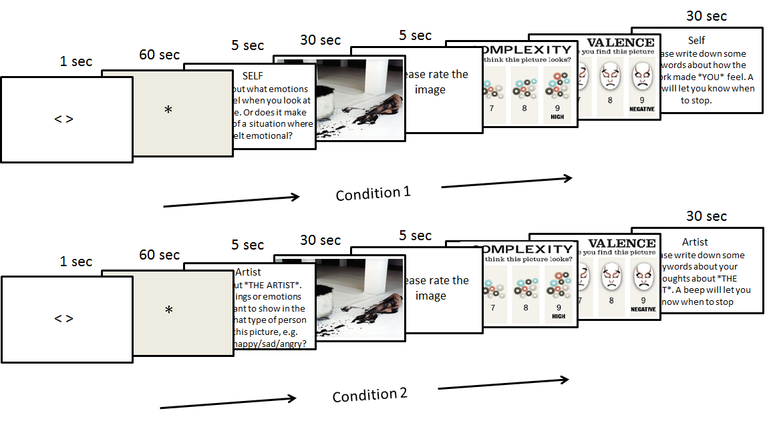
Figure 1. Time-line of the experiment for each condition (condition 1 = self, condition 2 = other).

2.4 Experimental Stimuli
Sixteen images (8 in a positive valence category, 8 in a negative valence category) were selected according to ratings of valence and complexity obtained during an online survey (N = 1028) (Kreplin & Fairclough, 2013). The mean valence ratings for positive images was 3.33 (s.d. 1.75) whereas negative images scored an average of 6.32 (s.d. 1.92). Subjective ratings of image complexity from the survey did not significantly differ between positive (mean 3.97, s.d. 2.06) and negative (mean 4.29, s.d. 1.97) images. Both groups of images were viewed under two conditions (self/other) making a total of four categories (positive self (PS), negative self (NS), positive other (PO) and negative other (NO) (Fig. 2).
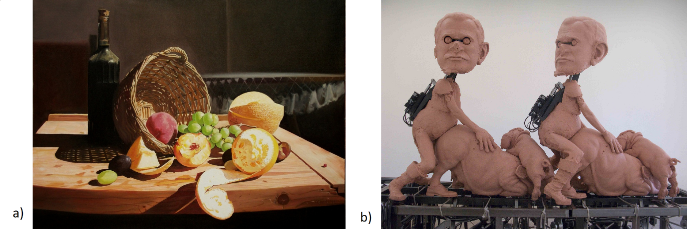
Figure 2. Examples of the stimuli assigned to the two valence categories (a) positive (Best Abstract © Adrian Borda) and (b) negative (Photo by Jason Kaufman, Los Angeles, 2010 (Paul McCarthy) © 2011).

Individual difference during the evaluation of visual art has been highlighted as a methodological problem in past studies (see Cupchik, Vartanian, Crawley, & Mikulis, 2009; Vessel et al., 2012). To obtain stimuli that were calibrated to maximise the differentiation between positive and negative images, a second level of selection was applied after the experimental protocol had been completed. The valence ratings from each participant were examined individually and only three out of four images that best corresponded with the positive and negative valence categories for both self- and other-conditions were used; i.e. the three images that scored highest for each participant (high valence scores = negative valence) in the negative-self and negative-other condition were used for subsequent analysis and the same procedure was applied to positive images. Twelve images (three in each of PS, NS, PO and NO) for each participant were included in the final data analysis. This procedure attempts to control for individual differences in the emotional evaluation of visual art (i.e. there might not be a clear consensus of the negativity/positivity of an image) to maximise the differentiation between the positive and negative categories of images.
2.5 fNIRS data collection
fNIRS was used to record haemoglobin changes using fNIR Imager1000 and COBI data collection suite (Biopac System Inc) which is described in detail elsewhere (Ayaz et al., 2011). The system is a continuous fNIRS device that has a temporal resolution of 2Hz and calculates haemoglobin changes according to a baseline taken before the stimulus onset. The 16-channel probe was placed on the forehead aligned to Fp1 and Fp2 of the international 10-20 system, and rotated so that Fpz corresponded to the midpoint of the probe (Ayaz et al., 2006) (Fig. 3). Areas underlying the 16 channels are right and left superior and inferior frontal gyrii (BA10 and BA46). Cognitive and emotional functions associated with BA10 and BA46 have been explored in previous work using a similar fNIRS device (León-Carrion et al., 2008; León-Carrión et al., 2007; Plichta et al., 2006).

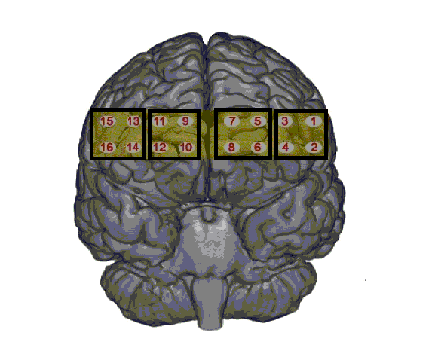
Figure 3. The 16 channels of the fNIRS probe located over the rostral PFC. Boxes indicate 4 Regions Of Interest (ROI) used in subsequent analyses.

The data were analysed offline using fNIRS-Soft (Ayaz et al, 2010). Raw data were subjected to a Sliding-window Motion Artefact Rejection (SMAR) algorithm, which is based upon the principal that raw optical signals have less variation than segments with motion artefact and saturated channels to remove motion artefacts and saturated channels (for details see Ayaz, Izzetoglu, Shewokis, & Onaral, 2010). A finite impulse response linear phase low-pass filter, with order 20 and cut-off frequency of 0.1 Hz was applied to attenuate high frequency noise, respiration and cardiac effects (Ayaz et al., 2010; Izzetoglu et al., 2007). The data were divided into 30 second segments using synchronization markers. For each 30 seconds of data oxygenated haemoglobin (HbO) and deoxygenated haemoglobin (HHb) were calculated relative to the baseline of 20 seconds collected during the rest period immediately before each stimulus onset using the modified Beer-Lambert Law. The 30 second segments were averaged according to category (PO, PS, NO, NS). Data was extracted to Excel for further analysis. Statistical analyses were conducted using SPSS v.21. Violations of sphericity were corrected via the Greenhouse-Geisser adjustment and outliers (any value that fell below -3SD or above 3SD from the mean) were excluded.
2.6 Region Of Interest (ROI) Analysis
A ROI analysis was performed to analyse the effects of the independent variables on rPFC activation. ROIs comprised of four channels and were defined as lateral-right (channel 1, 2, 3, 4), medial-right (channel 5, 6, 7, 8) and medial-left (channel 9, 10, 11, 12) and lateral-left (channel 13, 14, 15, 16) areas of the rPFC (Fig. 3).

- RESULTS

Subjective ratings post-level two image selection were subjected to a 2 (self/other) x 2 (positive/negative) ANOVA to verify that positive and negative images were seen as significantly different. The results revealed a main effect of valence (F(1,59) = 433.47, p=.001, η = .88) showing that negative images were perceived as significantly more negative than positive images. The valence ratings for each category of image were: NO (M = 7.30, s.d. 1.38), NS (M = 7.43, s.d. 1.19), PO (M = 3.15, s.d. 1.61) and PS (M = 2.83, s.d. 1.52). There was no significant effect due to self/other condition or any interaction effect.
A 2 (self/other) x 2 (positive/negative) ANOVA was conducted on each ROI separately for HbO and HHb. One outlier was removed from the analyses related to the medial-left and medial-right area. The series of ANOVAs using HbO as a dependent variable indicated a significant increase in the other-condition compared to the self-condition in three ROIs; lateral-right (F(1,19) = 6.59, p=.01, η = .25), medial-left (F(1,18) = 6.99, p=.01, η = .28) and lateral-left (F(1,19) = 11.26, p=.003, η = .37) (Fig. 4).
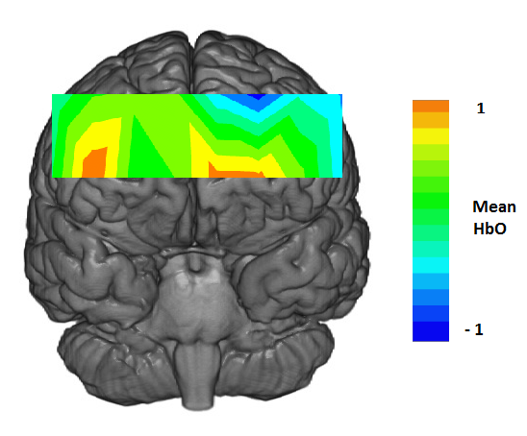
Figure 4. Main effect of condition in the HbO data. Heat-map represents mean values for other minus self condition (N=19)

Table 1 displays the mean values for each ROI of the HbO data for the self/other condition. The medial-right area showed a trend in the expected direction but did not reach significance (F(1,18) = 3.23, p=.08, η = .15).

Table 1. Mean HbO for each ROI for the self/other condition (N=19).
 | Lateral - Right |  | Medial - Right |  | Medial - Left |  | Lateral - Left
 | Mean | s.d. | Mean | s.d. | Mean | s.d. | Mean | s.d.
Other | 0.04 | 0.38 | -0.15 | 0.40 | -0.11 | 0.38 | 0.03 | 0.44
Self | -0.14 | 0.32 | -0.33 | 0.47 | -0.32 | 0.40 | -0.21 | 0.30

It should be noted that neural activation of an area is also reflected in a decrease of HHb. The ANOVA for HHb revealed no significant main effects. However, there was a significant interaction between valence and self/other in the lateral-right (F(1,18) = 8.62, p=.009, η = .32) and medial-right (F(1,17) = 6.17, p=.02, η = .26) ROI. One outlier was removed from the lateral- and two from the medial-right ROI. Post-hoc t-tests at the lateral-right ROI revealed that HHb was significantly reduced in the NO condition compared to NS (t(18) = 2.30, p=.03) and PO (t(18) = 2.13, p=.04). In addition, HHb was significantly lower in PS compared to the PO condition (t(18) = 2.62, p=.01).

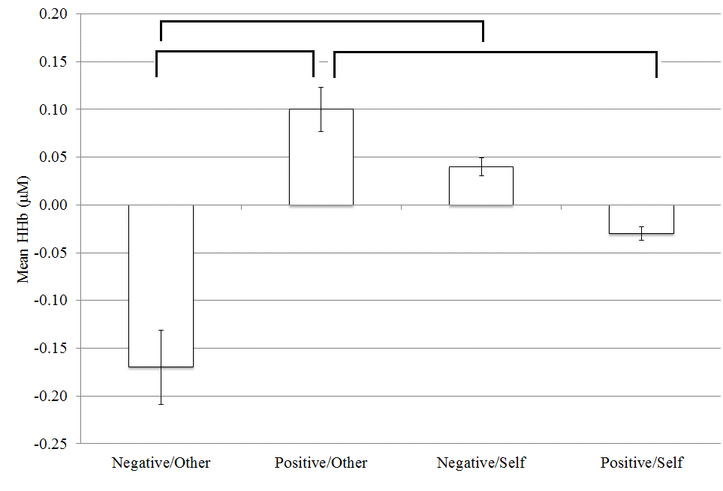
Figure 5. Mean HHb values for the lateral-right ROI of the rPFC. Error bars represent standard error (N=19). Brackets indicate statistically significant differences at p<.05.

Post-hoc t-tests at the medial-right ROI revealed that mean HHb was lower during the NO compared to NS condition (t(17) = 2.28, p=.03). In addition, mean HHb was lower in the PO compared to NS condition (t(17) = 2.12, p=.04) and reduced in the PS compared to NS condition (t(17) = 2.17, p=.04) (Fig. 6).

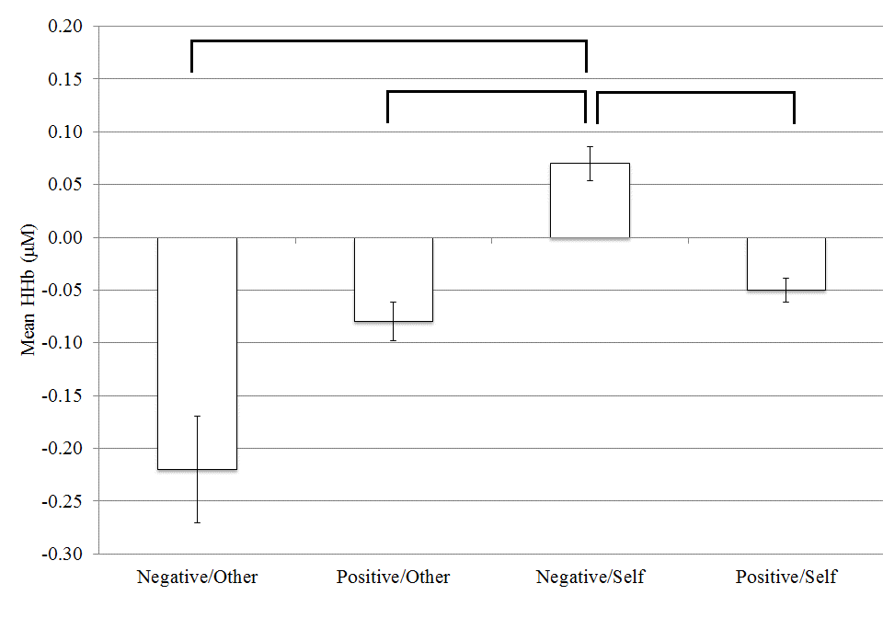
Figure 6. Mean HHb values for the medial-right ROI of the rPFC. Error bars represent standard error (N=18). Brackets indicate statistically significant differences at p<.05.

- DISCUSSION
We predicted greater activation of the medial rPFC (medial BA10) when artwork was processed from the perspective of the self (Vessel et al., 2012). Our results revealed the opposite effect as mean HbO was significantly higher during the other-condition in all but one of the ROIs under investigation (Fig. 4). This finding was partially supported by the analysis of mean HHb (Fig. 5 and 6), as the pattern of greater activation (i.e. lower HHb) during the other-condition was only apparent when the images were negative. In contrast, viewing a positive image during the self-condition led to a decrease of HHb (Fig. 5 & 6).
Estimating the intentions of another person is an important component of social interaction which has been highlighted via research on ToM (Blakemore & Decety, 2001; Carruthers & Smith, 1996; Mahy et al., 2014; Spreng et al., 2013). ToM is functionally equivalent to second-order intentionality (I believe that you suppose…) (Dunbar, 2012; Lewis, Rezaie, Brown, Roberts, & Dunbar, 2011) and this category of second-order processing was fundamental to the other-condition where participants were required to introspect about the emotional state of the artist. We found second-order processing to be associated with an increase of oxygenated haemoglobin in bilateral areas of the rPFC (Fig. 4). It is logical to assume that an estimation of second-order intentionality, i.e. ToM, represents a significantly higher level of cognitive demand compared to its first-order equivalent as the former necessitates a complex process of projection and simulation. Therefore, we assume that increased HbO in the rPFC represented a higher level of cognitive demand for this particular category of introspection.
The rPFC has been implicated in the act of orienting behaviour towards specific task aspects (Burgess, Dumontheil, & Gilbert, 2007; Cupchik et al., 2009). Research into prospective memory, in which intentions need to be maintained in memory for delayed execution, suggest a fine grained dissociation between the medial and lateral rPFC (Burgess et al., 2007; Christoff, Ream, Geddes, & Gabrieli, 2003), where lateral rPFC is involved in the maintenance of internally generated cognition. It has been found that lateral rPFC is involved in orienting attention to viewing images from an aesthetic viewpoint compared to viewing images from a pragmatic viewpoint (Cupchik et al., 2009). Cupchik et al. (2009) interpreted activation of the lateral rPFC with respect to the maintenance and execution of the internally generated goal to approach the artworks from an aesthetic orientation. Our results support this interpretation and suggest that our participants found it more challenging to maintain this goal when thinking about the negative emotions an artist wants to portray in a painting. This finding suggests that lateral rPFC is involved in the orientation of attention during aesthetic experience and attentional regulation was more challenging during second-order processing.
The decrease of HHb during the viewing of negative images in the other-condition could simply reflect increased rPFC activation due to cognitive demand associated with second-order processing. Alternatively, this finding could be provoked by the detection of ambiguity or threat when images had negative emotional connotations. There is research to support the position that thinking about other people in a state of distress evokes negative affect in the observer (Hatfield, Cacioppo, & Rapson, 1994); in addition, activation of the prefrontal cortex has been associated with the perception of real or imagined threat (Thom et al., 2014; Zink, Stein, Kempf, Hakimi, & Meyer-Lindenberg, 2010). The role of the rPFC in ToM has been highlighted by Jenkins et al., (2014) who found that patients with lesions to this area were significantly impaired with respect to the detection of emotions in others, particularly when the emotion was associated with fear. These results supports the hypothesis that the cognitive demand of second-order processing was intensified in the presence of negative emotion.
An earlier study (Kreplin & Fairclough, 2013) employing the same stimuli reported an increase of mean HbO at the medial area of the rPFC when participants viewed positive pictures. The current experiment revealed a significant decrease of HHb in the right medial area of the rPFC when participants viewed positive compared to negative images during the self-condition (Fig. 6). This effect could be related to the increase of HbO in response to positive images that was reported in the earlier study (Kreplin & Fairclough, 2013). However, there are methodological differences between the current study and the earlier one, for instance, participants in the initial study were instructed to focus on how the image made them feel as opposed to the instructions to evoke autobiographical memories used in the current experiment. Vessel et al. (2012; 2013) suggested that the medial rPFC is activated when an artwork ‘strikes a chord’ in the viewer signifying intense personal meaning. This effect observed in the current study could reflect a positivity bias wherein contemplation of positive emotional stimuli associated with the self are experienced as intrinsically rewarding. This bias, and its association to the prefrontal cortex, has been demonstrated by Viviani et al. (2010) in a scrambled sentences task.
The design of the current study permitted only a relative comparison between the influence of positive and negative images on rPFC activation. Therefore, the contrast between HHb for positive vs. negative images (Fig. 6) could be interpreted as increased activation in response to positive valence or a deactivation of the rPFC when participants were asked to contemplate negative images in the self-condition. The latter interpretation could be indicative of a strategy of active disengagement with negative material that relates to distancing and the use of active self-regulation to inhibit a negative emotional experience (Baumeister, Bratslavsky, Muraven, & Tice, 1998; Baumeister, 2014). However, this interpretation is problematic because an attempt to actively suppress an emotional responses should lead to an increase in HbO in the rPFC as this self-regulatory process is known to require cognitive effort (Goldin, McRae, Ramel, & Gross, 2008).
There is currently no strong consensus in the literature regarding the optimal parameter of brain activation that can be derived from fNIRS data (Scholkmann et al., 2014). Research investigating emotional processes using fNIRS has reported significant changes in the PFC for HbO alone (Leon-Carrion et al., 2006), for HHb alone (Ernst, Weidner, Ehlis, & Fallgatter, 2012) or for both HbO and HHb (Glotzbach et al., 2010). It has been argued that HHb is sensitive to local haemodynamic changes, less prone to influences from psychophysiological noise, such as breathing or heart rate and has a close association with the blood oxygenation dependent (BOLD) signal obtained from fMRI (Ernst et al., 2013; Izzetoglu, Bunce, Izzetoglu, Onaral, & Pourrezaei, 2007; Plichta et al., 2006). However, HbO is the parameter which is less sensitive to variation in probe placement due to head size and shape because HbO activation is more global compared to HHb activation (Hoshi, 2005; Plichta et al., 2006; Scholkmann et al., 2014; Wobst, Wenzel, Kohl, Obrig, & Villringer, 2001). The different characteristics of the HbO and HHb parameters accounts for a global activation pattern for HbO and more sensitivity to regional changes in HHb found in this study.
There were several limitations associated with the current study. The absence of a neutral category of image (from the perspective of emotional valence) was a major limitation as we could only compare the impact of positive images relative to negative ones. All results are therefore differential effects between images with positive vs. negative valence. Although a neutral category was included during pilot testing it became apparent that variability in the subjective ratings rendered this category of images unusable and it was excluded from the final protocol. It is possible to generate visual stimuli that do not provoke a positive or negative emotional response, e.g. black and white geometrical patterns. However, it is questionable whether this type of stimuli possesses the same degree of ecological validity as the genuine artworks used as stimuli in the current study.
The experimental design did not include measures that enabled us to test whether participants were able to perform the self/other task and how individual differences may have influenced our results in this respect. Some participants may have been more engaged or more efficient with regard to emotional introspection despite the inclusion of a training phase. The recruitment of individuals only excluded participation if the person possessed a qualification in art but did not control for individual difference with respect to prior exposure to artworks through gallery visits. It may also be of interest to investigate the emotional interaction and the self/other related processing in other participant groups such as art experts compared to art naïve participants as the latter may use more emotional and self-referential processing compared to the former (Leder et al., 2004).
To summarise, this study provided evidence of bilateral activation (greater HbO) of the rPFC when visual art was viewed from the perspective of another compared to the self. An interaction found in the HHb data indicated a bias towards negative images that are interpreted from the perspective of the other, and towards positive images processed from the perspective of the self. There was no evidence of any main effect of emotional valence of the image on rPFC activation. These early results require further work to understand whether the pattern of bilateral activation observed in the rPFC is a product of increased cognitive demand in a general sense or more specific processes and how this interacts with the emotional valence.

ACKNOWLEDGEMENTS
This work was partly funded by the European Commission as part of ICT-2009.4.1 (Digital Libraries and Digital Preservation) under the ARtSENSE project (270318). We would also like to acknowledge the comments and guidance received from the anonymous reviewers during the preparation of this manuscript.

REFERENCES
Amting, J. (2010). Multiple Mechanisms of Consciousness: The Neural Correlates of Emotional Awareness. The Journal of Neuroscience, 30(30), 10039–10047. doi:10.1523/JNEUROSCI.6434-09.2010
Andrews-Hanna, J. R. (2012). The brain’s default network and its adaptive role in internal mentation. The Neuroscientist : A Review Journal Bringing Neurobiology, Neurology and Psychiatry, 18(3), 251–70. doi:10.1177/1073858411403316
Andrews-Hanna, J. R., Reidler, J. S., Sepulcre, J., Poulin, R., & Buckner, R. L. (2010). Functional-anatomic fractionation of the brain’s default network. Neuron, 65(4), 550–62. doi:10.1016/j.neuron.2010.02.005
Araujo, H. F., Kaplan, J., & Damasio, A. (2013). Cortical Midline Structures and Autobiographical-Self Processes: An Activation-Likelihood Estimation Meta-Analysis. Frontiers in Human Neuroscience, 7(September), 548. doi:10.3389/fnhum.2013.00548
Ayaz, H., Izzetoglu, M., Platek, S. M., Bunce, S., Izzetoglu, K., Pourrezaei, K., & Onaral, B. (2006). Registering fNIR data to brain surface image using MRI templates. Conference Proceedings : ... Annual International Conference of the IEEE Engineering in Medicine and Biology Society. IEEE Engineering in Medicine and Biology Society. Conference, 1, 2671–4. doi:10.1109/IEMBS.2006.260835
Ayaz, H., Izzetoglu, M., Shewokis, P. A., & Onaral, B. (2010). Sliding-window motion artifact rejection for Functional Near-Infrared Spectroscopy. Conference Proceedings : ... Annual International Conference of the IEEE Engineering in Medicine and Biology Society. IEEE Engineering in Medicine and Biology Society. Conference, 2010, 6567–70. doi:10.1109/IEMBS.2010.5627113
Ayaz, H., Shewokis, P. A., Curtin, A., Izzetoglu, M., Izzetoglu, K., & Onaral, B. (2011). Using MazeSuite and functional near infrared spectroscopy to study learning in spatial navigation. Journal of Visualized Experiments : JoVE, (56). doi:10.3791/3443
Baumeister, R. F. (2014). Self-regulation, ego depletion, and inhibition. Neuropsychologia, 65, 313 – 319. doi:doi:10.1016/j.neuropsychologia.2014.08.012
Baumeister, R. F., Bratslavsky, E., Muraven, M., & Tice, D. M. (1998). Ego depletion: Is the active self a limited resource? Journal of Personality and Social Psychology, 74(5), 1252 – 1265.
Benoit, R. G., Gilbert, S. J., Volle, E., & Burgess, P. W. (2010). When I think about me and simulate you: medial rostral prefrontal cortex and self-referential processes. NeuroImage, 50(3), 1340–9. doi:10.1016/j.neuroimage.2009.12.091
Berlyne, D. E. (1960). Conflict, Arousal, and Curiosity. London: McGraw-Hill Book Company.

Blakemore, S. J., & Decety, J. (2001). From the perception of action to the understanding of intention. Nature Reviews Neuroscience, 2, 561 – 567.
Buckner, R. L., Andrews-Hanna, J. R., & Schacter, D. L. (2008). The brain’s default network: anatomy, function, and relevance to disease. Annals of the New York Academy of Sciences, 1124, 1–38. doi:10.1196/annals.1440.011
Burgess, P. W., Dumontheil, I., & Gilbert, S. J. (2007). The gateway hypothesis of rostral prefrontal cortex (area 10) function. Measuring the Mind: Speed, Control, and Age, 11(7), 290–8. doi:10.1016/j.tics.2007.05.004
Carruthers, P., & Smith, P. K. (1996). Theories of theories of mind. Cambridge: Cambridge University Press.
Christoff, K., Ream, J. M., Geddes, L. P. T., & Gabrieli, J. D. E. (2003). Evaluating self-generated information: anterior prefrontal contributions to human cognition. Behavioral Neuroscience, 117(6), 1161–8. doi:10.1037/0735-7044.117.6.1161
Cupchik, G. C., Vartanian, O., Crawley, A., & Mikulis, D. J. (2009). Viewing artworks: contributions of cognitive control and perceptual facilitation to aesthetic experience. Brain and Cognition, 70(1), 84–91. doi:10.1016/j.bandc.2009.01.003
Denny, B. T., Kober, H., Wager, T. D., & Ochsner, K. N. (2012). A Meta-analysis of Functional Neuroimaging Studies of Self- and Other Judgments Reveals a Spatial Gradient for Mentalizing in Medial Prefrontal Cortex. Journal of Cognitive Neuroscience, 24(8), 1742–1752.
Dolcos, F., LaBar, K. S., & Cabeza, R. (2004). Dissociable effects of arousal and valence on prefrontal activity indexing emotional evaluation and subsequent memory: an event-related fMRI study. NeuroImage, 23(1), 64–74. doi:10.1016/j.neuroimage.2004.05.015
Dunbar, R. I. M. (2012). The social brain meets neuroimaging. Trends in Cognitive Sciences, 16(2), 101–2. doi:10.1016/j.tics.2011.11.013
Engle, J. S. (1904). Analytic Interest Psychology and Synthetic Philosophy. Baltimore: King Brothers.
Ernst, L. H., Plichta, M. M., Lutz, E., Zesewitz, A. K., Tupak, S. V, Dresler, T., … Fallgatter, A. J. (2013). Prefrontal activation patterns of automatic and regulated approach-avoidance reactions - a functional near-infrared spectroscopy (fNIRS) study. Cortex; a Journal Devoted to the Study of the Nervous System and Behavior, 49(1), 131–42. doi:10.1016/j.cortex.2011.09.013
Ernst, L. H., Weidner, A., Ehlis, A., & Fallgatter, A. J. (2012). Controlled attention allocation mediates the relation between goal-oriented pursuit and approach – avoidance reactions to negative stimuli. Biological Psychology, 91(2), 312–320. doi:10.1016/j.biopsycho.2012.08.004
Freedberg, D., & Gallese, V. (2007). Motion, emotion and empathy in esthetic experience. Trends in Cognitive Sciences, 11(5), 197–203. doi:10.1016/j.tics.2007.02.003
Gibbs Jr., R. W. (2006). Embodiment and cognitive science. New York: Cambridge University Press.
Gilbert, S. J., Spengler, S., Simons, J. S., Frith, C. D., & Burgess, P. W. (2006). Differential functions of lateral and medial rostral prefrontal cortex (area 10) revealed by brain-behavior associations. Cerebral Cortex (New York, N.Y. : 1991), 16(12), 1783–9. doi:10.1093/cercor/bhj113
Glotzbach, E., Muehlberger, A., Gschwendtner, K., Fallgatter, A. J., Pauli, P., & Herrmann, M. J. (2010). Prefrontal Brain Activation During Emotional Processing: A Functional Near Infrared Spectroscopy Study (fNIRS). The Open Neuroimaging Journal, 5, 33–39.
Goldin, P. R., McRae, K., Ramel, W., & Gross, J. J. (2008). The neural bases of emotion regulation: reappraisal and suppression of negative emotion. Biological Psychiatry, 63(6), 577–86. doi:10.1016/j.biopsych.2007.05.031
Hatfield, E., Cacioppo, J., & Rapson, R. (1994). Emotional contagion. Current Directions in Psychological Science, 2(3), 96–99. doi:10.1086/322897
Hoshi, Y. (2005). Functional near-infrared spectroscopy: potential and limitations in neuroimaging studies. International Review of Neurobiology, 66(05), 237–66. doi:10.1016/S0074-7742(05)66008-4
Izzetoglu, M., Bunce, S. C., Izzetoglu, K., Onaral, B., & Pourrezaei, K. (2007). Functional brain imaging using near-infrared technology. IEEE Engineering in Medicine and Biology Magazine : The Quarterly Magazine of the Engineering in Medicine & Biology Society, 26(4), 38–46.
Jenkins, L. M., Andrewes, D. G., Nicholas, C. L., Drummond, K. J., Moffat, B. A., Phal, P., … Kessels, R. P. C. (2014). Social cognition in patients following surgery to the prefrontal cortex. Psychiatry Research, 224(3), 192–203. doi:10.1016/j.pscychresns.2014.08.007
Kirk, U., Skov, M., Christensen, M. M. S., & Nygaard, N. (2009). Brain correlates of aesthetic expertise: a parametric fMRI study. Brain and Cognition, 69(2), 306–15. doi:10.1016/j.bandc.2008.08.004
Kompus, K., Hugdahl, K., Ohman, A., Marklund, P., & Nyberg, L. (2009). Distinct control networks for cognition and emotion in the prefrontal cortex. Neuroscience Letters, 467(2), 76–80. doi:10.1016/j.neulet.2009.10.005
Kreplin, U., & Fairclough, S. H. (2013). Activation of the rostromedial prefrontal cortex during the experience of positive emotion in the context of esthetic experience. An fNIRS study. Frontiers in Human Neuroscience, 7(December), 879. doi:10.3389/fnhum.2013.00879
Krienen, F. M., Tu, P.-C., & Buckner, R. L. (2010). Clan mentality: evidence that the medial prefrontal cortex responds to close others. The Journal of Neuroscience : The Official Journal of the Society for Neuroscience, 30(41), 13906–15. doi:10.1523/JNEUROSCI.2180-10.2010
Leder, H. (2013). Next steps in neuroaesthetics: Which processes and processing stages to study? Psychology of Aesthetics, Creativity, and the Arts, 7(1), 27–37. doi:10.1037/a0031585
Leder, H., Belke, B., Oeberst, A., & Augustin, D. (2004). A model of aesthetic appreciation and aesthetic judgments. British Journal of Psychology (London, England : 1953), 95(Pt 4), 489–508. doi:10.1348/0007126042369811
Lee, K. H., & Siegle, G. J. (2012). Common and distinct brain networks underlying explicit emotional evaluation: a meta-analytic study. Social Cognitive and Affective Neuroscience, 7(5), 521–34. doi:10.1093/scan/nsp001
Leon-Carrion, J., Damas, J., Izzetoglu, K., Pourrezai, K., Martín-Rodríguez, J. F., Barroso y Martin, J. M., & Dominguez-Morales, M. R. (2006). Differential time course and intensity of PFC activation for men and women in response to emotional stimuli: a functional near-infrared spectroscopy (fNIRS) study. Neuroscience Letters, 403(1-2), 90–5. doi:10.1016/j.neulet.2006.04.050
León-Carrion, J., Damas-López, J., Martín-Rodríguez, J. F., Domínguez-Roldán, J. M., Murillo-Cabezas, F., Barroso Y Martin, J. M., & Domínguez-Morales, M. R. (2008). The hemodynamics of cognitive control: the level of concentration of oxygenated hemoglobin in the superior prefrontal cortex varies as a function of performance in a modified Stroop task. Behavioural Brain Research, 193(2), 248–56. doi:10.1016/j.bbr.2008.06.013
León-Carrión, J., Martín-Rodríguez, J. F., Damas-López, J., Pourrezai, K., Izzetoglu, K., Barroso y Martin, J. M., & Domínguez-Morales, M. R. (2007). A lasting post-stimulus activation on dorsolateral prefrontal cortex is produced when processing valence and arousal in visual affective stimuli. Neuroscience Letters, 422(3), 147–52. doi:10.1016/j.neulet.2007.04.087
Lewis, P. A., Rezaie, R., Brown, R., Roberts, N., & Dunbar, R. I. M. (2011). Ventromedial prefrontal volume predicts understanding of others and social network size. NeuroImage, 57(4), 1624–9. doi:10.1016/j.neuroimage.2011.05.030
Mahy, C. E. V, Moses, L. J., & Pfeifer, J. H. (2014). How and where: Theory-of-mind in the brain. Developmental Cognitive Neuroscience, 9C, 68–81. doi:10.1016/j.dcn.2014.01.002
Mitchell, D. G. V. (2011). The nexus between decision making and emotion regulation: a review of convergent neurocognitive substrates. Behavioural Brain Research, 217(1), 215–31. doi:10.1016/j.bbr.2010.10.030
Molnar-Szakacs, I., & Uddin, L. Q. (2013). Self-Processing and the Default Mode Network: Interactions with the Mirror Neuron System. Frontiers in Human Neuroscience, 7(September), 571. doi:10.3389/fnhum.2013.00571
Ochsner, K. N., & Gross, J. J. (2005). The cognitive control of emotion. Trends in Cognitive Sciences, 9(5), 242–9. doi:10.1016/j.tics.2005.03.010
Pelowski, M., & Akiba, F. (2011). A model of art perception, evaluation and emotion in transformative aesthetic experience. New Ideas in Psychology, 29(2), 80–97.
Plichta, M. M., Herrmann, M. J., Baehne, C. G., Ehlis, A.-C., Richter, M. M., Pauli, P., & Fallgatter, A. J. (2006). Event-related functional near-infrared spectroscopy (fNIRS): are the measurements reliable? NeuroImage, 31(1), 116–24. doi:10.1016/j.neuroimage.2005.12.008
Scholkmann, F., Kleiser, S., Metz, A. J., Zimmermann, R., Mata Pavia, J., Wolf, U., & Wolf, M. (2014). A review on continuous wave functional near-infrared spectroscopy and imaging instrumentation and methodology. NeuroImage, 85 Pt 1, 6–27. doi:10.1016/j.neuroimage.2013.05.004
Silvia, P. (2012). Human emotions and aesthetic experience: An overview of empirical aesthetics. In A. Shimamura & S. Palmer (Eds.), Aesthetic science: Connecting minds, brains, and experience. (pp. 250–275). Oxford University Press: Oxford.
Spreng, R. N., Sepulcre, J., Turner, G. R., Stevens, W. D., & Schacter, D. L. (2013). Intrinsic architecture underlying the relations among the default, dorsal attention, and frontoparietal control networks of the human brain. Journal of Cognitive Neuroscience, 25(1), 74–86. doi:10.1162/jocn_a_00281
Thom, N. J., Johnson, D. C., Flagan, T., Simmons, A. N., Kotturi, S. A., Van Orden, K. F., … Paulus, M. P. (2014). Detecting emotion in others: Increased insula and decreased medial prefrontal cortex activation during emotion processing in elite adventure racers. Social Cognitive and Affective Neuroscience, 9(2), 225–231.
Vessel, E. A., Starr, G. G., & Rubin, N. (2013). Art reaches within: aesthetic experience, the self and the default mode network. Frontiers in Neuroscience, 7(December), 258. doi:10.3389/fnins.2013.00258
Vessel, E., Starr, G. G., & Rubin, N. (2012). The brain on art: intense aesthetic experience activates the default mode network. Frontiers in Human Neuroscience, 6(April), 66. doi:10.3389/fnhum.2012.00066
Viviani, R., Lo, H., Sim, E., & Beschoner, P. (2010). The neural substrate of positive bias in spontaneous emotional processing. PLoS One, 5(11), 1–9. doi:10.1371/journal.pone.0015454
Völlm, B. A., Taylor, A. N. W., Richardson, P., Corcoran, R., Stirling, J., McKie, S., … Elliott, R. (2006). Neuronal correlates of theory of mind and empathy: a functional magnetic resonance imaging study in a nonverbal task. NeuroImage, 29(1), 90–8. doi:10.1016/j.neuroimage.2005.07.022
Wobst, P., Wenzel, R., Kohl, M., Obrig, H., & Villringer, a. (2001). Linear aspects of changes in deoxygenated hemoglobin concentration and cytochrome oxidase oxidation during brain activation. NeuroImage, 13(3), 520–30. doi:10.1006/nimg.2000.0706
Zink, C. F., Stein, J. L., Kempf, L., Hakimi, S., & Meyer-Lindenberg, A. (2010). Vasopressin modulates medial prefrontal cortex-amygdala circuitry during emotion processing in humans. The Journal of Neuroscience : The Official Journal of the Society for Neuroscience, 30(20), 7017–7022.

